Grazioso Salvare

Shelter Database Dashboard

About the Project/Project Title
Grazioso Salvare specializes in identifying dogs for search and rescue missions across a broad range of scenarios and terrain. This dashboard is built specifically for accessing local animal shelter databases within the Austin, Texas region with filters to assist in locating excellent candidates based on breed, age, and sex. It is equipped with an interactive map showing which shelter selected animals are located, as well as a breakdown of the current filtered items breed distribution.

Motivation
Certain dog breeds can be incredibly effective in search and rescue missions, particularly in regions that are difficult to access by vehicles such as water, mountains, wilderness, and other natural disasters. Dogs with heightened tracking senses can find individuals in need of assistance faster than human search and rescue teams potentially saving lives. Identifying dogs with these skillsets, especially those in shelters, is not only providing these dogs with a future but also a service to remote regions in need of emergency services.

Tools Utilized & Rationale
MongoDB 8.3.2
We chose to use MongoDB for several reasons beyond just its compatibility with the Python programming language. Our project utilizes a Model-View-Controller pattern and MongoDB is the model layer responsible for all the storage and retrieval of data in combination with our CRUD module. This database management system utilizes BSON documents which work seamlessly with Python’s dictionary data type. The Community edition of their server is provided at no cost, which is ideal for low overhead and potentially non-profit organizations’ usage. Lastly its impressive query capabilities allow for one read() call to intake all the data necessary for filtering the somewhat incomplete data into a perfectly structured response.

PyMongo 4.17.0
When using MongoDB for database management systems, we are required to use the PyMongo driver which allows all the CRUD API and other various database interactions to work efficiently. It intakes a standard dict and returns a list of dicts reducing the need for any conversions and providing seamless communication of queries and CRUD support.

Dash & JupyterDash
Working within the Jupyter Notebook the Dash and JupyterDash API are necessary for the layout of the dashboard and eliminate the need for extra html files or unnecessary conversions. They are Python native therefore streamline the communication between PyMongo and Panda building a highly efficient framework for the project. Dash is responsible for the view and controller components in our MVC pattern, utilizing app.layout to display and organize the data table, map, pie chart, and overall aesthetic. With @app.callback we can monitor any interactions the user may make and update all the data tables and visualizations accordingly.

dash-leaflet
Ideal renderer for components over OpenStreetMap due to its tile layer support. Provides tooltip marker and popup data layer for selected rows on database.

Plotly Express

Provides the dynamic pie chart capabilities requested displaying the breed distributions of the current dataframe’s filtered results.

Pandas
Handles communication between MongoDB and Dash, converting lists of dicts from PyMongo into DataFrames. Additionally, executes the dropping of columns such as removal of _id and the checking of empty data cells.

Getting Started
To begin using this database management system locally on your personal computer follow these steps:
- Ensure you have MongoDB installed and ready to go by visiting http://www.mongodb.com/ and creating a user account.
- Access repository through GitHub and download necessary files to preferred location.
- Verify your desired Python IDE is up to date with the necessary dependencies for using MongoDB.
- Organize your data into .csv file and import it into MongoDB.
- Ensure all assets are in the proper folders including CRUD module & Grazioso Salvare logo.
- Run the frontend Python management application.
- Utilize built out CRUD (Create, Read, Update, Delete) functionality in combination with PyMongo to manage database through detailed searches.

Installation
MongoDB 8.3.2 - https://www.mongodb.com/try/download/community
- Download and run the MongoDB Community Server .msi installer.
- Through Codio interface and pre-installation use:
  - mongod –port 27017 –dbpath /usr/local/var/mongodb

PyMongo 4.17.0 - https://pypi.org/project/pymongo/#files
- Install via terminal/pip:
  - python -m pip install pymongo

Dash – https://dash.plotly.com/installation
- Install via terminal/pip:
  - pip install dash

JupyterDash - https://pypi.org/project/jupyter-dash/
- Install via terminal/pip:
  - $ pip install jupyter-dash

dash-leaflet - https://www.dash-leaflet.com/
- Install via terminal/pip:
  - pip install dash-leaflet

Plotly Express - https://plotly.com/python/plotly-express/
- Installed as plotly via terminal/pip:
  - pip install plotly

Pandas - https://pandas.pydata.org/docs/getting_started/install.html
- Installed via terminal/pip:
  - pip install pandas

Usage
Dashboard Examples
Starting screen of dashboard displays first 10 entries of the unfiltered database.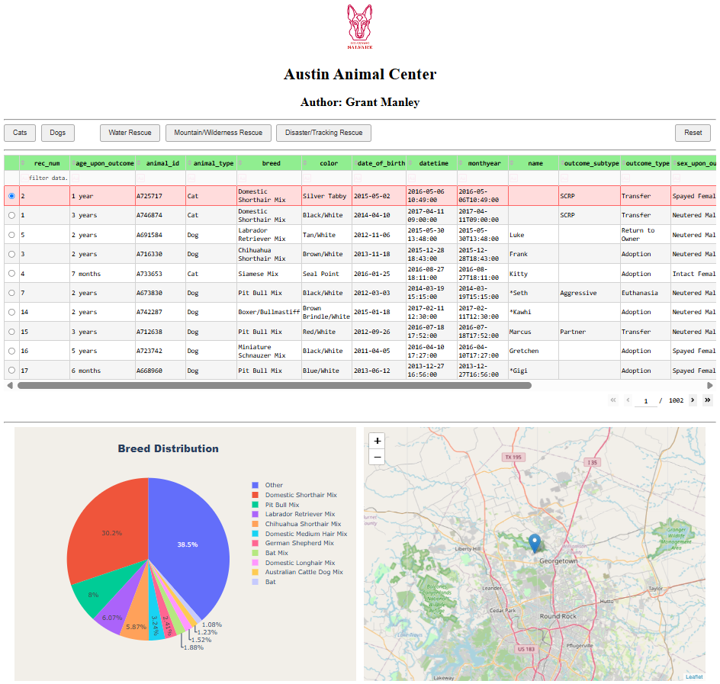

Dashboard layout with Water Rescue filter on
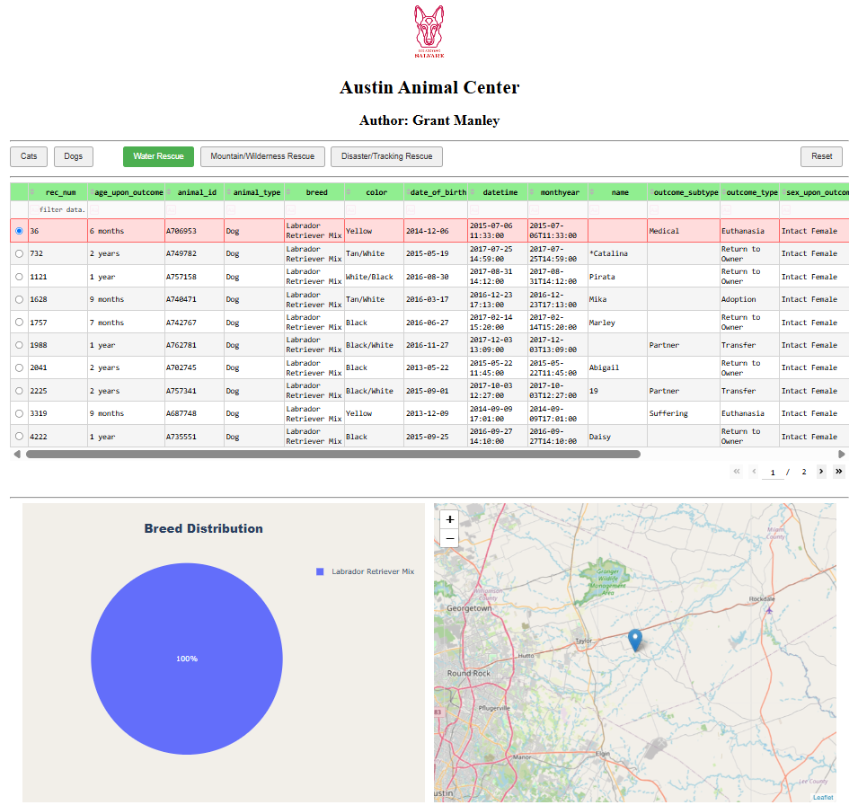

Dashboard layout with Mountain/Wilderness Rescue filter on
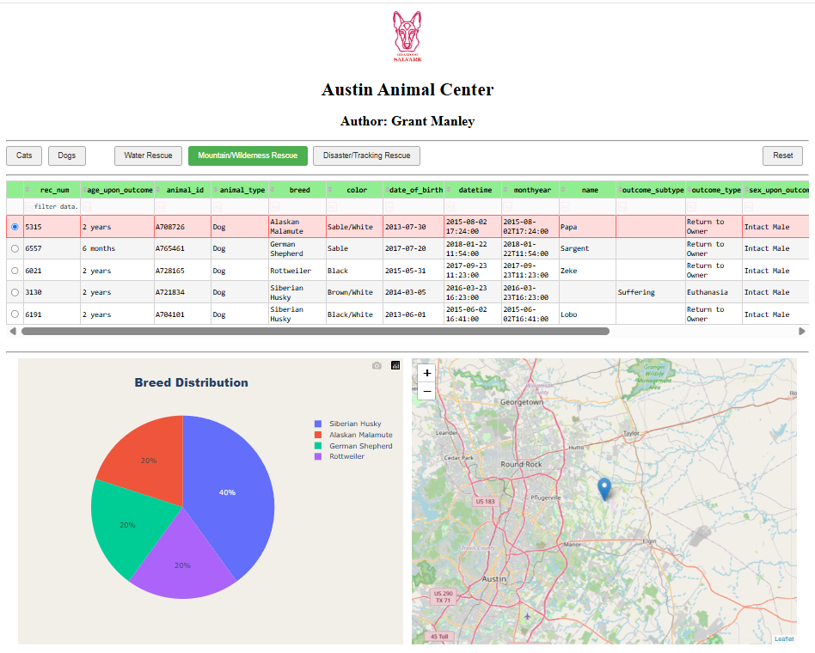

Dashboard layout with Disaster/Tracking Rescue filter on:
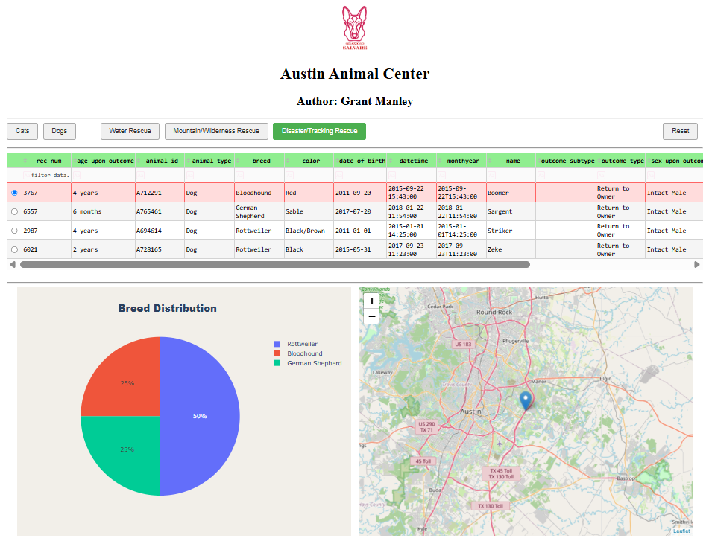

Screenshot after clicking reset, back to original state
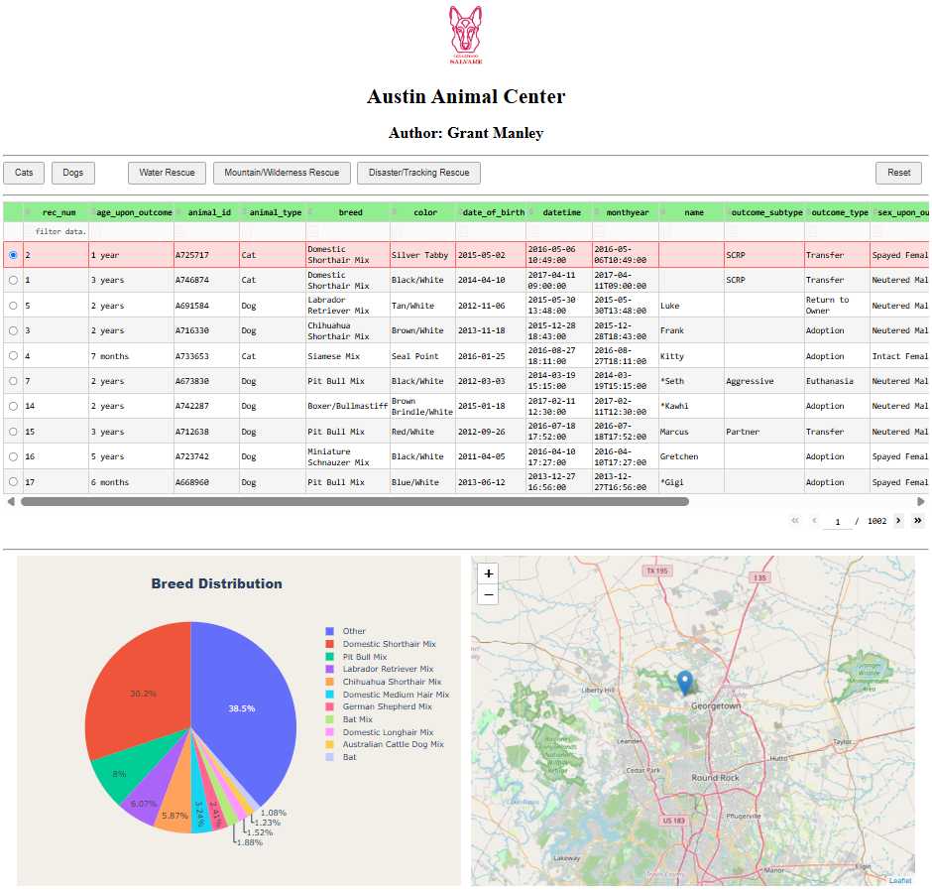

Code Example
Import Database:
This command selects a particular database and collection before defining the file type to be imported in.
mongoimport –db aac –collection animals –type csv –headerline
–file datasets/aac_shelter_outcomes.csv
Create New User:
The createUser() method accepts a username, password, and roles, returning a 1 for successful completion.
db.createUser({user: “example_user_name”, pwd: “user_pw”,
roles: [ { role: “readWrite”, db: “aac” } ] } )
Create a new shelter:
Creation of a new shelter objects with user authentication.
shelter = AnimalShelter(“aacuser”, “aacuserpw1”)

Add a new animal to database:
Input new animal into database with available data at time utilizing dict type data format.
new_animal = {
"age_upon_outcome": "3 years",
"animal_type": "Dog", …
… "outcome_type": "Transfer",
"sex_upon_outcome": "Neutered Male"
}
shelter.create(new_animal)

Read animal in database:
Search for documents matching queries in dict data type. Returns list.
shelter.read({"name": "Silly Wizard"})

Update animal in database:
Updates documents matching identifiers in dict type query with new_data dict. Returns modified documents count.
shelter.update({"name": "Eric Barkman"},
{"age_upon_outcome": "2 years",
"date_of_birth": "2024-03-22"})

Remove adopted animal from database:
Deletes all documents matching dict type query. Returns count of documents deleted.
shelter.delete({"name": "Eric Barkman"})

Tests

Create method test:
result = shelter.create(new_animal = {
"age_upon_outcome": "3 years",
"animal_type": "Dog", …
… "outcome_type": "Transfer",
"sex_upon_outcome": "Neutered Male"
})
print("New Animal Added:", result, "\n")

Read method test:
result = shelter.read({"name": "Silly Wizard"})
print("Read Result: \n", result)

Update method test:
result = shelter.update({"name": "Eric Barkman"},
{"age_upon_outcome": "2 years",
"date_of_birth": "2024-03-22"})
print("Update Result # of Documents Modified:", result,
"\n\n-- Updated Entry --- \n",
shelter.read({"name": "Eric Barkman"}), "\n")

Delete method test:
result = shelter.delete({"name": "Eric Barkman"})
print("Deleted Result # documents removed:", result,
"\n\nRead attempt to confirm deletion: ",
shelter.read({"name": "Eric Barkman"}))

Additional Screenshots
Import collection:
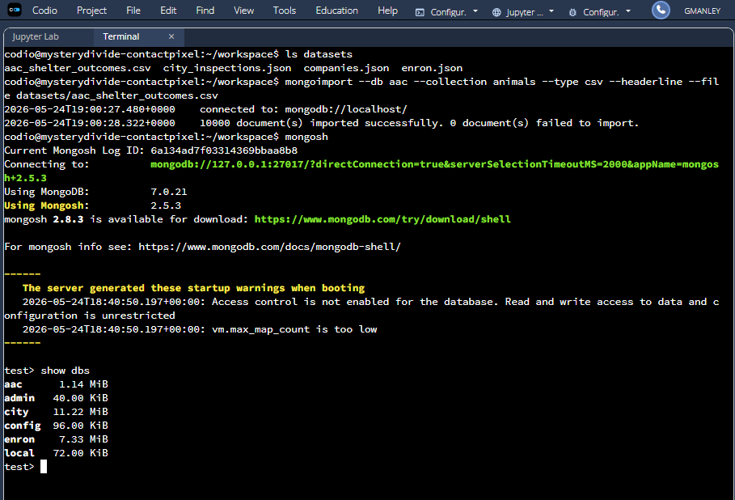

Create new user:
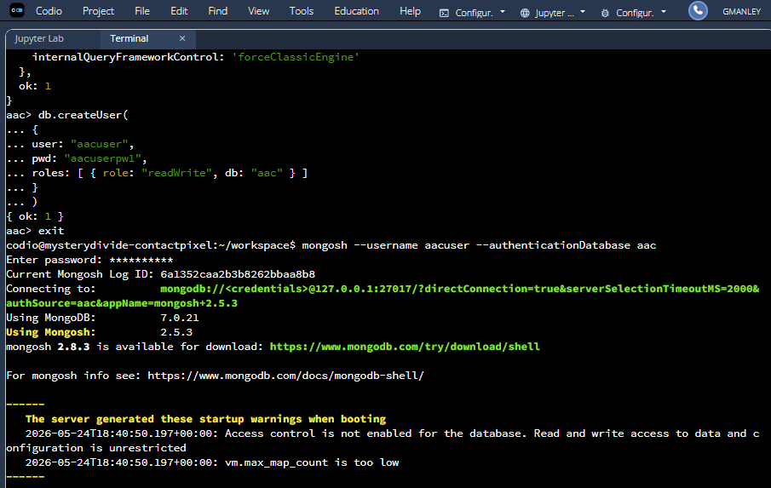

Create method example:
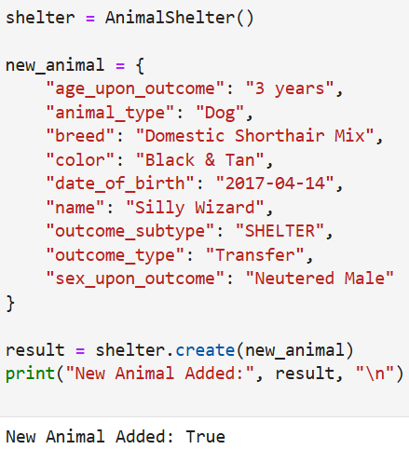

Read method example:
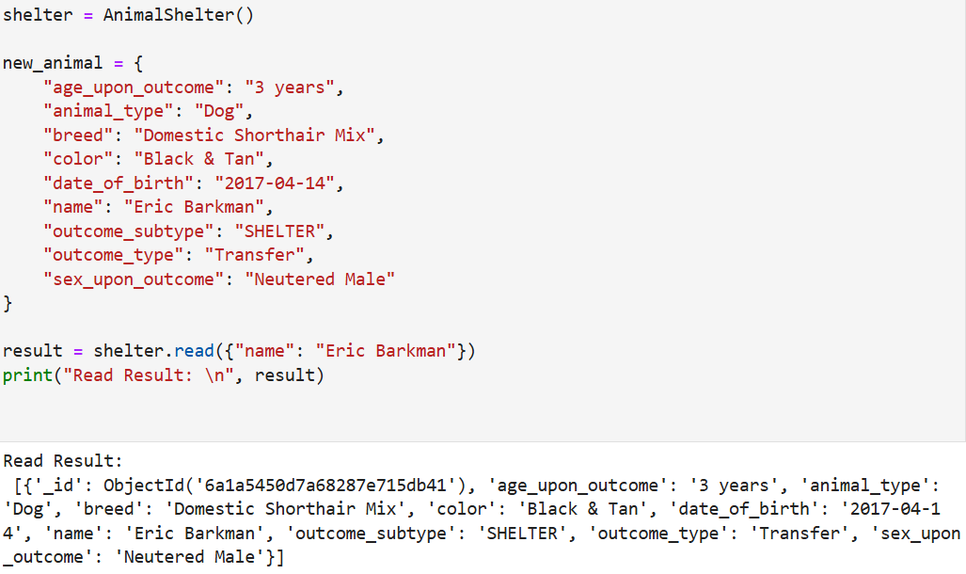
Update method example:
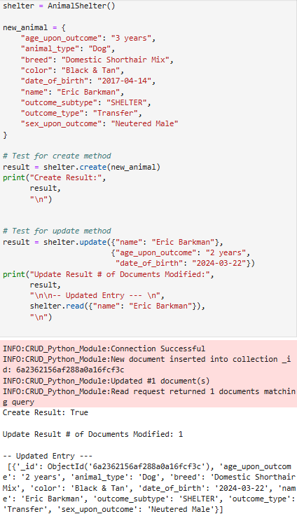

Delete method example:
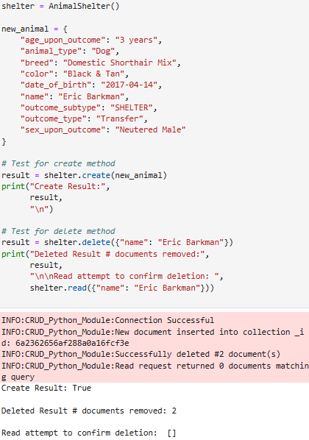

Steps taken to complete the project

MongoDB was set up in Codio with the required database, collection, username/password, and subsequent permissions granted.
- AnimalShelter CRUD module was built to manage create, read, update, delete functionality with the necessary validation and authentication checks.
- Dashboard was created with Dash DataTable implementing basic filtering options.
- Enhanced filtering through use of toggled buttons for Grazioso Salvare’s specific needs.
- Additional widgets of map for location of specific selected animals with leaflet support, and Plotly Express pie chart displaying breed distribution of currently filtered results on DataTable.
- Dashboard tested thoroughly to ensure all buttons and filters worked properly while maintaining their stylings and alignments.

Challenges Encountered
- Two callbacks were complicating each other when attempting to make an entire row highlight when clicked. This was resolved by creating one function in charge of both filtering and styling.
- Button logic for toggling on and off became dysfunctional when reset button was added into the mix. This was fixed by creating dcc.Store component which stored a list of all the currently active buttons.
- Data Sheet Print method in the works for printing and organizing data in an easy-to-read fashion for potential forever families to read.
- When aligning the reset button to the far-right side, callbacks to the style caused the button to shift back to the left. This was resolved by adding a final reset button style dictionary with marginLeft: ‘auto’.
- Creating the proper path for the Grazioso Salvare logo to display properly was an issue. Resolved by adding an assets/ folder to the proper directory.

Roadmap/Features
- Add pictures of rescue dogs to database and dashboard.
- Add a heat map overlay to show spread-out of animals when more than one is selected.
- Add options for different data visualizations other than breed selection.
- Add options for different data visualizations other than pie chart layout.

Contact
Grant Manley
https://github.com/cali4nia3

